**The Staff:**

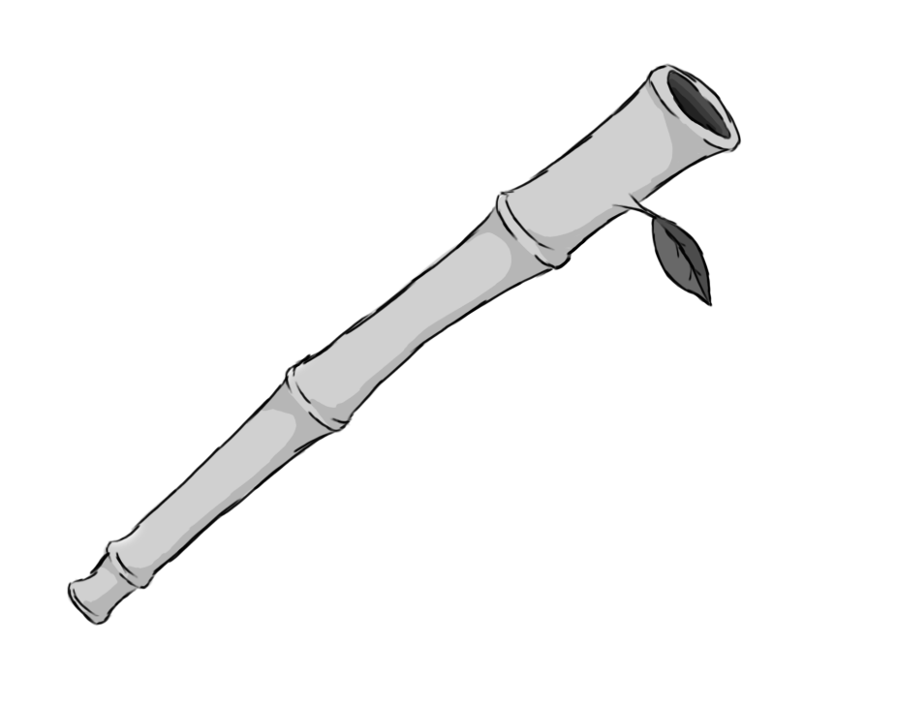

Figure 1 - Weapon: Staff

**Brief Synopsis**

The staff is a low damage, yet high-speed, combo weapon. Its basic attacks can be continued into several more attacks by pressing the attack button repeatedly. The staff is also able to return any projectile attacks fired at the player while attacking.

**Special Ability**

**Hover:**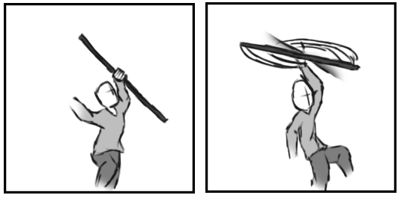

Figure - Animation Storyboard: Hover

**Special:** When aerial, the player swings their staff above, creating a helicopter blade effect. This slows the decent of the player, allowing them to reach further areas that the double jump might fail to grant them access to.

**Combat Abilities**

**Continuous strikes:   
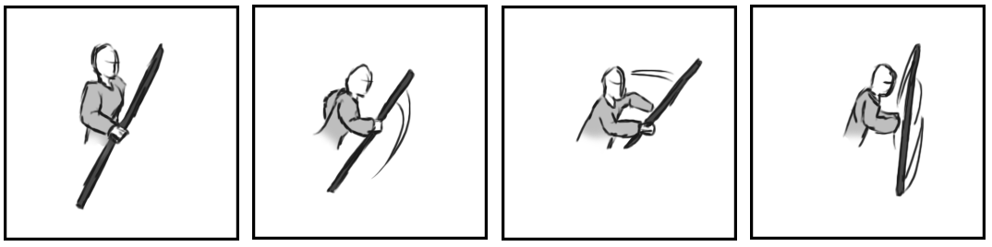**

Figure 3 - Animation Storyboard: Continuous Strikes

**While grounded and stationary**: The player swings the staff quickly, attacking anything in front of them. Each strike can reflect any projectile launched at the player.

**Running Strike:  
**

Figure 4 - Animation Storyboard: Running Strike

**While grounded and in motion:** Like the continuous strikes, except movement is maintained while swinging. Can also reflect projectiles.

**Downward strike:**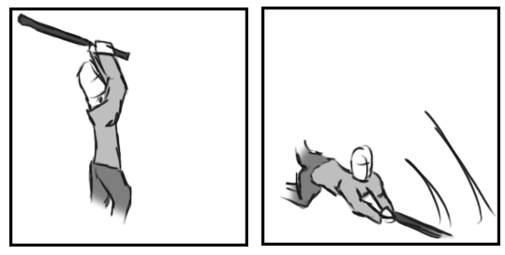

Figure - Animation Storyboard: Downward Strike

**While aerial:** The player slams the staff down to the ground, attacking enemies directly in front of them.